RadModtCC
Cell-centered Radially Symmetric FD model

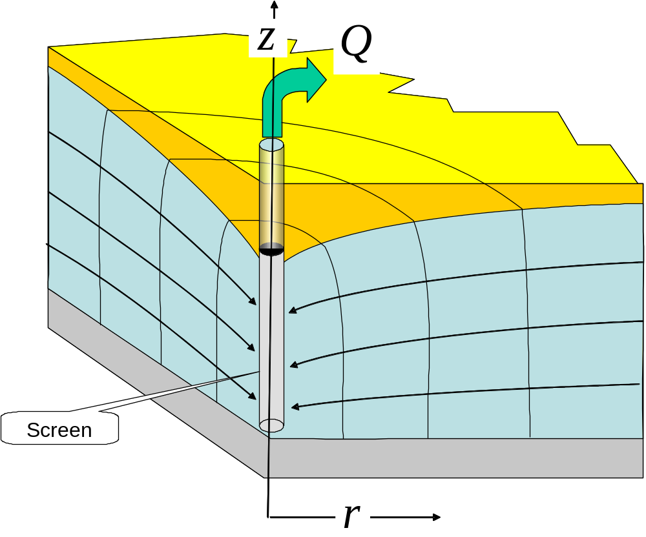

T.N.Olsthoorn
Table of Contents
1 Summary and conclusions 1
2 Introduction 1
3 Use and input 2
4 Output 3
5 Implementation 4
6 References 5

Summary and conclusions
RadmodtCC is an effective tool for modeling radially symmetric flow. It may be used for studying special flow situations in the vicinity of well screens, multilayer models and for interpreting complicated pumping tests. The model has also been successfully applied for analysis of delayed yield pumping tests in unconfined aquifers. Also large diameter well tests may be simulated with this model.

Introduction
RadModtCC is a Cell-centered radially symmetric finite difference groundwater model. Radial symmetry is built in for high accuracy computations. The mesh can be made as fine as needed, so can the time scale.
The input is kept simple so that adapting or setting up a model for a specific situation is straight forward. This is also used to compare the model with analytic solutions of Theis and Hantush as well as delayed yield.
RadModtCC is one of a series. There also exists a RadModt, which is a mesh centered fininite difference radially symmetric model. RadModt has the nodes (the locations where sources, sinks and heads are defined, in the corners of the cells (Figure 1), while RadModtCC has the nodes in the center of the cells (Figure 2). There are advantages and disadvantages to mesh-centered versus cell-centered models. One is that in the mesh-centered model the node locations area exactly defined and the outer nodes also coincide with the circumference of the model. In the mesh centered model this it not directly clear. On the other hands, the flows between cells (at the cell boundaries) are clearly defined in the mesh centered model, which allows a more straightforward computation of balances of cells and velocities. These latter motives led to the construction of the current model. To alleviate the location of the nodes on the boundary, the model is constructed such that the outer nodes coincide with the first coordinates as is shown in Figure 3).
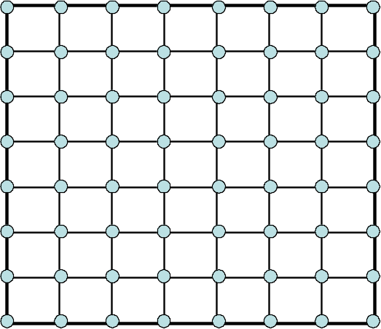
Figure 1: Mesh-centered model
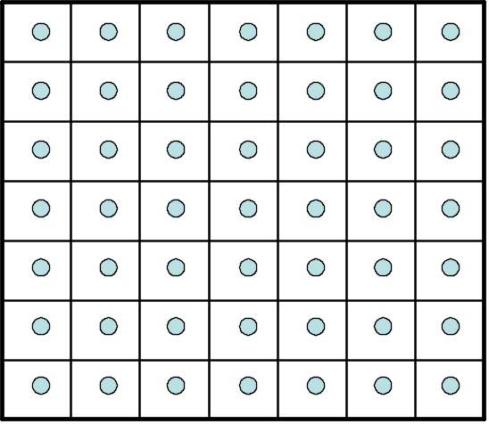
Figure 2: Cell-centered model
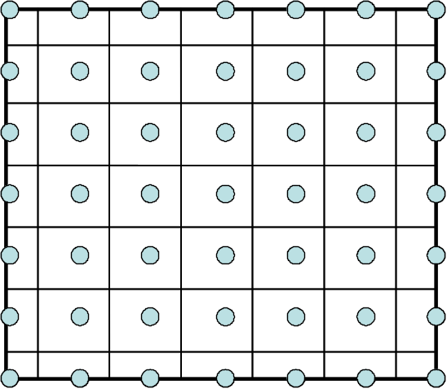
Figure 3: Current model

Use and input
The mode is implemented in Matlab and run as a Matlab function
[Phi,APhi,QR,QZ]=radmodtCC(r,z,t,kr,kz,ss,FH,FQ,Phi0,theta)
The input are matrices except theta, which is a values between 0 (explicit computation in time) and 1 (fully implicit computation in time). It is advised to use one combined by a fine enough time-spacing to that jumps in time-boundary conditions are well captured. Often the best thing to do is use a logarithmically increasing time scale, which may be done using the Matlab function logspace(…).
r and z are the coordinates of the horizontal and vertical grid lines, not the hearts of the cells. In this model the outer cell nodes are on the first and last coordinates, the other cell nodes in the center between theses coordinates. For contouring use
rm=0.5*(r(2:end)+r(1:end-1)), rm(1,end)=r(1,end);
zm=0.5*(z(2:end)+z(1:end-1)),zm(1,end)=z(1,end);
The model runs for t(2..end) and stores Phi0 as Phi(:,:,1) as the start values.
The other matrices have size of the number of cells size(length(zm),length(rm)).
FH specifies nodes (cells) with fixed heads. FH is a matrix with NaN’s, except for the cells with a fixed head. The non-NaN’s in FH are interpreted as fixed heads.
FQ specifies injection in cells. Use zero for no source or sink.
Phi0 specifies initial heads.

Output
Phi: The heads Phi as a 3D-matrix: Phi(Nz,Nr,Nt)
Q: 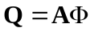 is the flow through the model from the nodes during the time step as defined, the result of the matrix multiplication. This flow, away from a node through the model equals the sum of the injection into the node (from the outside world) minus the storage at the node.
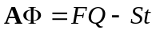
For steady-state:
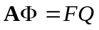
The injection can be a fixed flow or one computed for a fixed head.
To get all net injections, compute
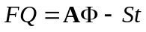
QR is the flow across the cell faces in r-direction [L3/T] QR(Nz,Nr+1,Nt)
QZ is the flow across the cell faces in z-direction [L3/T] QZ(Nz,Nr+1,Nt)
The outer cells have zero. If the flows from the nodes are in reality across the outer cell faces use those. For instance:
QR(:,1,:)=Q(:,1,:); QR(:,end,:)=Q(:,end,:);
St is the storage during the previous time step (first time = all zeros) last time is storage during the last time step.
Balance
Contouring may be done. For instance look for the range of contours and than contour:
M=max(Phi(:)); m=min(Phi(:)); N=50; C=[m:,(M-m)/N.M];
contour(rm,zm,Phi(:,:,it));

Implementation
The model is built from the water balance of a cell. The horizontal flow from between two nearby points in the same layer can be specified as
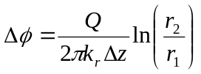
Now considering that two nodes are one cell apart, we computed the resistance to flow between the nodes as the sum of the resistance from the center of cell i to the center of cell i+1. Because the flow is in series, resistances may be added:
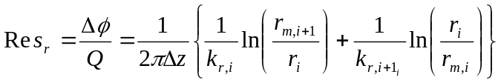
Where rm is the coordinate of plane between two cells and r are the coordinates of the cell centers. The coordinates of the outer cell centers are replaced by those of the outer coordinates of the cell boundaries to put the cells nodes on the left an right face of the model.
The conductance is then just
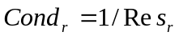
Vertically, the resistance is
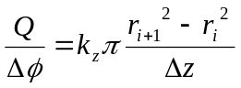
Likewise
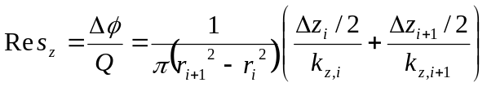
where r_{i} is the left face coordinate of cell i. Here too, to make sure that the outer nodes are on the outer boundary of the model cells, 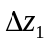 and 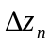 are not divided by two.
Here too, the vertical conductance equals
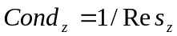
The matrix coefficient for the storage equals
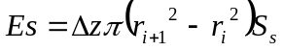
The horizontal flow through the cell faces is computed with the computed heads
The net flow to each node follows from
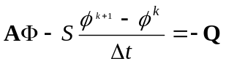
the storage in the cells equal
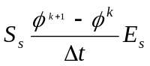
The flow through vertical cell faces equals

Delayed yield
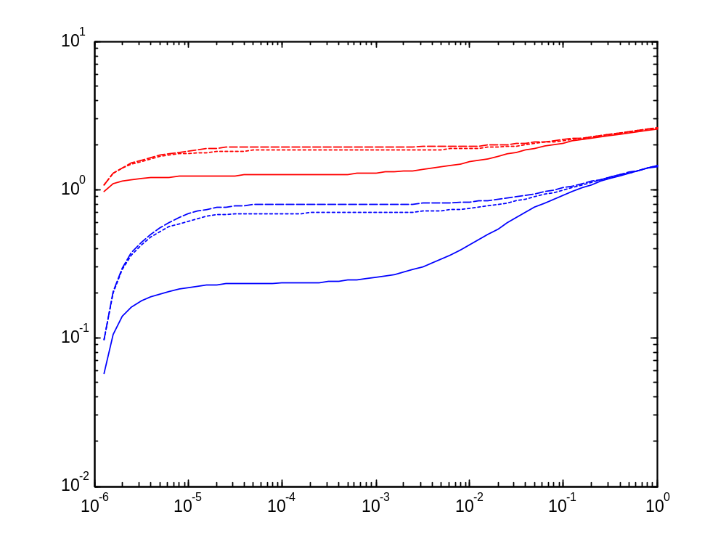
Figure 4: Computed drawdown due to 200 m3/d pumping test in 10 m/d 8 m thick unconfined aquifer, similar to the phreatic practical in the Lutte field work campaign of the VU in 2005. The well about 7 m deep was pumped, in the order of 200 m3/d. Observations were done in piezometers at about 60 cm distance from the well. Here the drawdown is shown at 60 cm depth (continuous lines), 4 m depth (small dashes) and 8 m depth (larger dashes). The blue lines are for piezometers at the well face, the blue lines for piezometers as 60 cm distance.
The difference between the drawdown and the well faces is obvious. More interesting is the difference with depth. Because during early time the water table works as a fixed-head boundary there is a large effect of depth of the piezometer, at least for the shallow ones. Also, there is a markedly delayed yield effect. During the time of the pumping test only the early drawdown could be measured. 10⁻² d is about 15 minutes. It should take about 0.2 days or 300 minutes before the phreatic phase fully sets in. In this way, the pumping test has hardly any use. The test should proceed for 100 minutes or more before the drawdown is interpretable with Theis.

References

